**Creating host in Zabbix server**

* Log into your Zabbix server
* Navigate to the Configuration tab in the top menu.

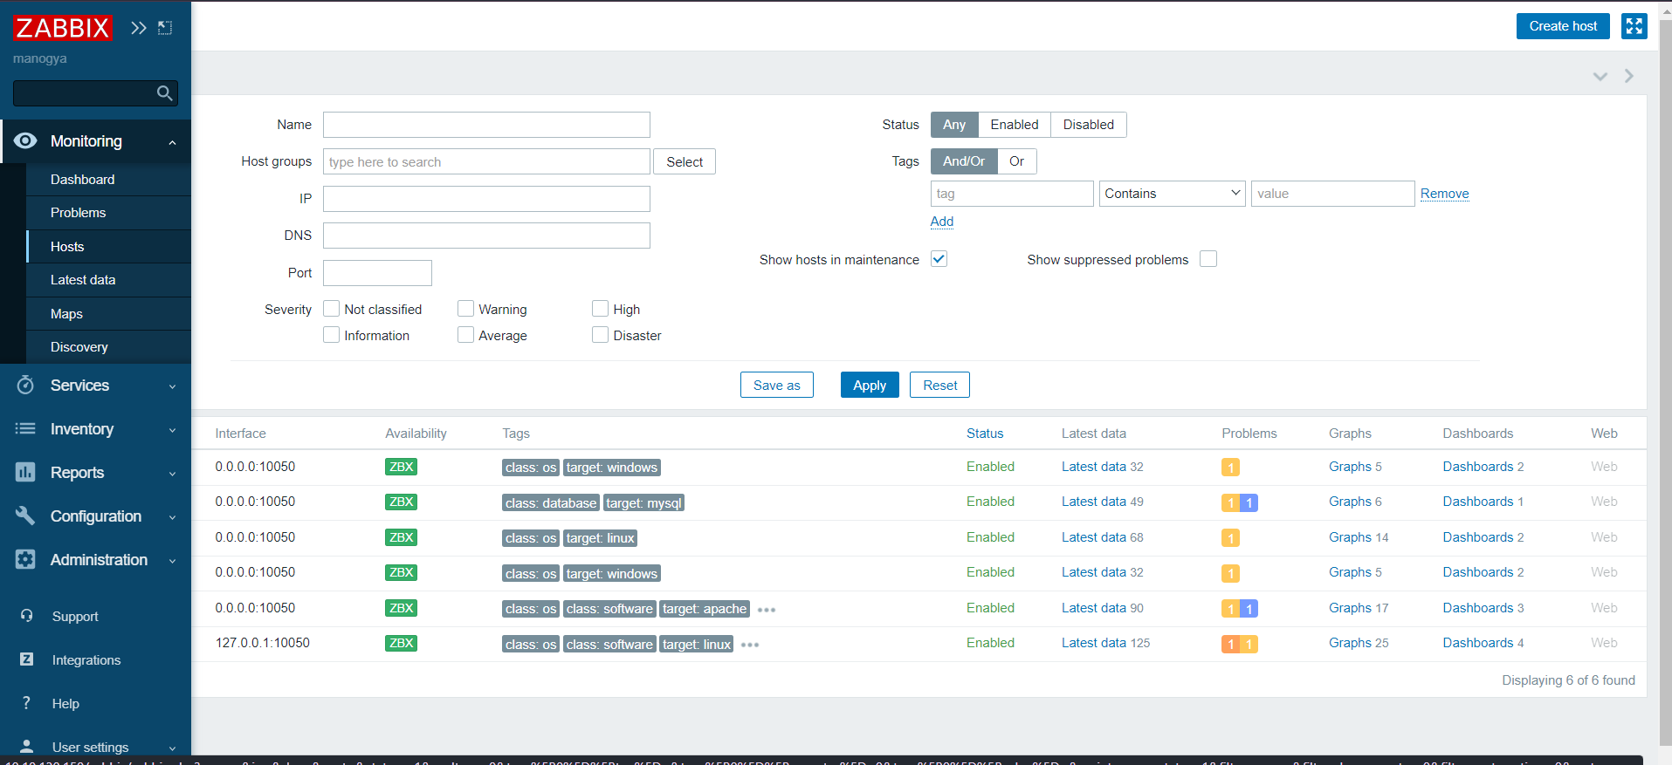

* Click on the “Create Host “Tab

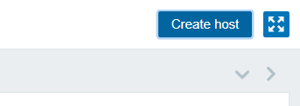

* you will need to fill in the necessary information for the host

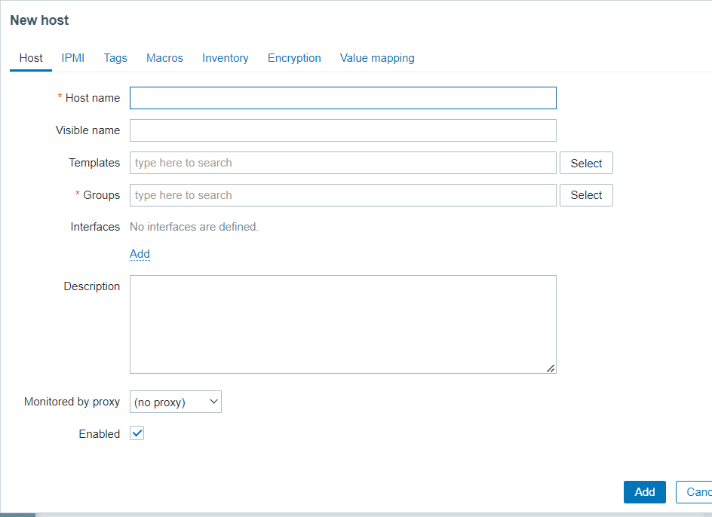

* Think of a name for the host, Type that name in the "Host name" field.
* Next, you need to pick a group for your host.
* Now, enter the IP address or DNS name of the host in the "IP address" field.
* use the default port for the monitoring method you choose or you can set it to 0.0.0.0
* Select the monitoring method from the options available, like Zabbix agent, SNMP, JMX, and others in templet option
* At last click “Add" button to save the host configuration.

